**Deployment & Interface Design - Improve the Road Safety in Breda**

Ron L. Tabuchov

Mohamed K. A. M. Elshami

Daria Vlăduţu

Peter Husen

Data Science and Artificial Intelligence, Breda University of Applied Science

Academy/Department

Saturday 01 January 2022

Index

Index 2

1 Background 3

2 Goal 3

3 Method 3

4 Deployment - Environment Creation 4

5 Code Cleaning 7

6 Unit Testing 8

7 Interface Design 10

# Background

This document outlines the deployment and interface design of models used within an AI system developed to improve road safety in Breda. As we provide a detailed description of the deployment process and the interface design strategies employed to enhance the user experience and overall system effectiveness.

# Goal

The goal of this file is to document the steps taken in the deployment and interface design phases of the project to improve road safety in Breda. This is to fulfil regulatory requirements and to ensure user-friendly usage, providing assurance that the system will effectively enhance their driving safety.

# Method

To ensure effective deployment and interface design for the road safety AI system in Breda, the process begins with defining hypotheses to determine what to test and the expected outcomes. The experiment design involves randomly assigning users to either Version A or B of the interface. Data collection follows, gathering feedback on a scale from 1 to 7, which is then analysed by calculating means, standard deviations, and performing t-tests. Based on these results, the interface is adjusted through iterative improvements to continuously refine the design. A demo application prototype is developed and tested to finalize the interface.

For deployment, the first step is creating a virtual environment to ensure isolation and consistency, followed by installing the necessary dependencies. Code cleaning involves refactoring to optimize performance and readability. Unit testing is conducted by developing and automating test cases to ensure all functionalities work as expected. The final deployment includes deploying the application to the cloud for scalability and availability, setting up monitoring tools to track performance, and providing user training along with comprehensive documentation to facilitate effective system use.

# Deployment - Environment Creation

Creating an isolated virtual environment is a critical step in the deployment process of the road safety AI system in Breda. This environment ensures that the deployment process is consistent and does not interfere with existing systems. A virtual environment provides a dedicated space where all dependencies and libraries specific to the project can be installed and managed independently of other projects. This isolation helps in avoiding conflicts between different software versions and configurations that may exist on the host system.

First step taken was to install poetry in our virtual server using the terminal:



when package installation is complete, we write the TOML file that specify which additional packages are need for the environment:

When running the command “# install poetry” in the right directory, poetry will locate the TOML file, read it and run installation for the mentioned packages:



Installation of the packages will begin, and the terminal will provide the status of each package:

Poetry.lock is created or updated during this process. This file locks the exact versions of all dependencies (including sub-dependencies) used in your project:

To confirm the last package installation, we use the command “# poetry show” in the terminal, as it provides a list of the current packages in the environment.

For last, we save the environment and assign a name to it by writing the following command in the server’s terminal # poetry run python -m ipykernel install --user --name PoetryEnvironment --display-name "Poetry Environment"

# Code Cleaning

Code cleaning is the process of restructuring existing computer code without changing its external behaviour. This involves making the code more readable, maintainable, and efficient. Good code cleaning practices help developers understand the code better, reduce complexity, and eliminate redundant or obsolete code, which ultimately leads to fewer bugs and easier maintenance. Example for used code cleaning for our project:

# Unit Testing

Unit testing is a software testing method where individual units or components of the software are tested in isolation to ensure they function correctly. The main goal is to validate that each unit of the software performs as expected and to identify any issues early in the development process.

**Setup the Testing Environment:**

Installed necessary testing libraries, including unittest for writing and running tests and coverage for measuring code coverage.

**Created Test Cases:**

Developed test cases in test_main_script.py to validate the functionality of different components of the main_script.py module.

Ensured each test case targets a specific function or feature, such as data loading, data preprocessing, model training, and evaluation.

**Running the Tests:**

Executed the test suite using unittest to verify that all test cases pass, and the software behaves as expected.

Utilized the coverage tool to run the tests and collect coverage data, ensuring that all parts of the code are tested.

**Generating and Viewing Coverage Reports:**

GeneratedwasHTML coverage report using coverage html to visually inspect which parts of the code were covered by the tests.

Opened the generated htmlcov/index.html file in a web browser to review the detailed coverage report, identifying areas with insufficient test coverage.

By implementing unit testing and achieving 55% code coverage, we ensured that our AI system for road safety in Breda is robust, reliable, and maintainable, providing assurance that the model will help users drive more safely.

# Interface Design

**Data Analysis:**

We used the following steps for data analysis:

* **Combine Data**: Integrate data from both versions into a single dataset.
* **Calculate Descriptive Statistics**: Compute means and standard deviations for each question for both versions.
* **Perform T-tests**: Conduct t-tests to compare the means of the two groups for each question.

[Link to AB-test analysis](https://github.com/BredaUniversityADSAI/2023-24d-fai1-adsai-teamwork-t18/blob/main/User%20testing/AB-test%20Analysis.ipynb)

**Results:**

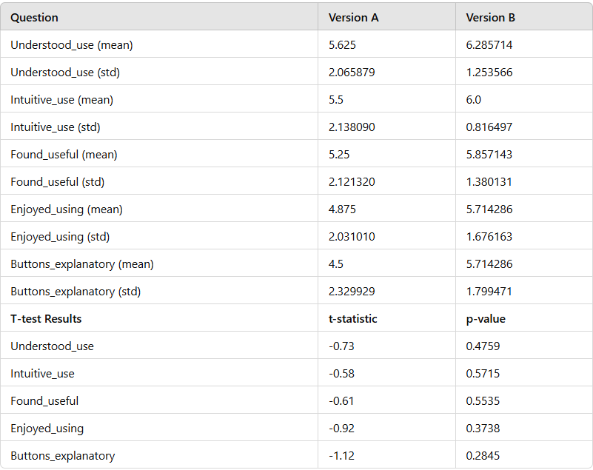

**Adjustments:**

Based on the findings from the A/B test, several adjustments were made to improve the app's user experience.

#### Addition of RAAI Button

* **Feature**: A Road Assistance using Artificial Intelligence (RAAI) button was added in the driving mode.
* **Functionality**: Users can turn the RAAI feature on or off by pressing this button.
* **Purpose**: The RAAI feature provides enhanced road assistance, aiming to improve safety and user convenience.
* **User Feedback**: Preliminary feedback from users who tested the RAAI feature has been positive, indicating that it adds significant value to the driving mode experience.

**Conclusion:**

The results indicate that Version B tends to have higher mean scores across all questions compared to Version A, despite the p-values indicating that the differences are not statistically significant at a conventional level. However, the consistent higher scores for Version B suggest a preference for Version B among users.

Based on the analysis of the data, Version B is preferred over Version A due to higher average ratings in all measured aspects. While the statistical significance is not strong, the trend in the data indicates that Version B provides a better user experience overall.